Step 2 Notes (HTML 1-4)

<p> = opening Tag
</P> = Closing Tag

Whole thing is an Element

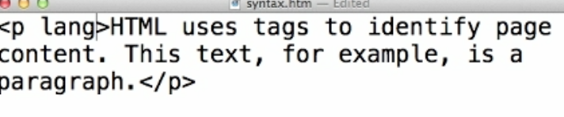

language is an Attribute
en = is the value

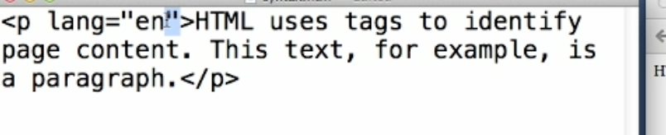

Nesting = making a parent and child relationship em=italicized
Child element has to close first
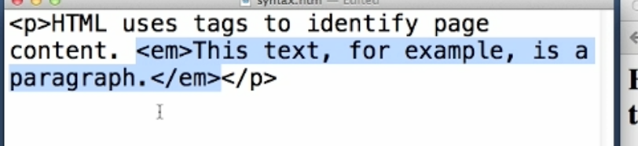
Strong = Bold
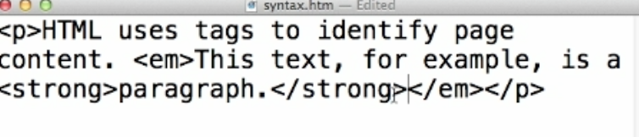

W3C Standards. These are the specifications and it is more for developers
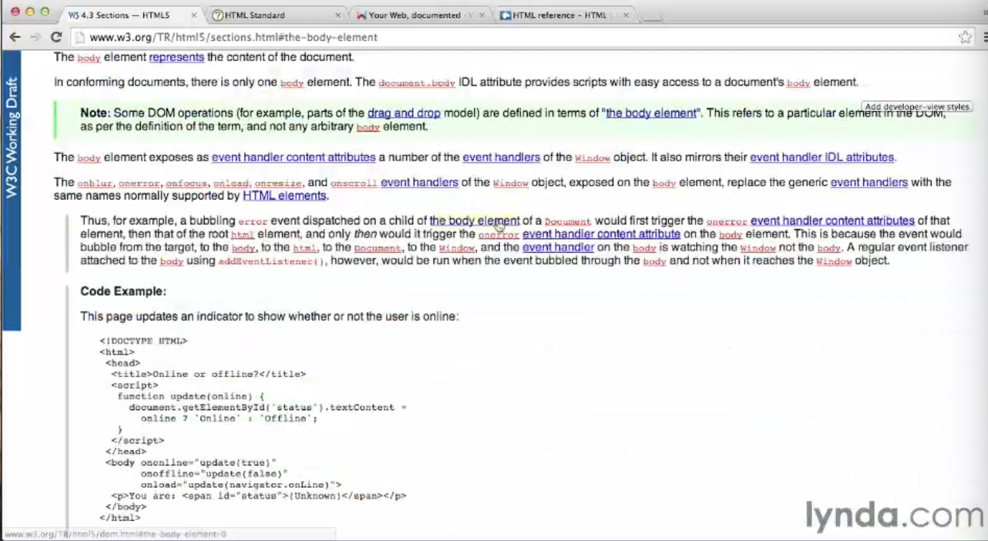

Open source website that is good
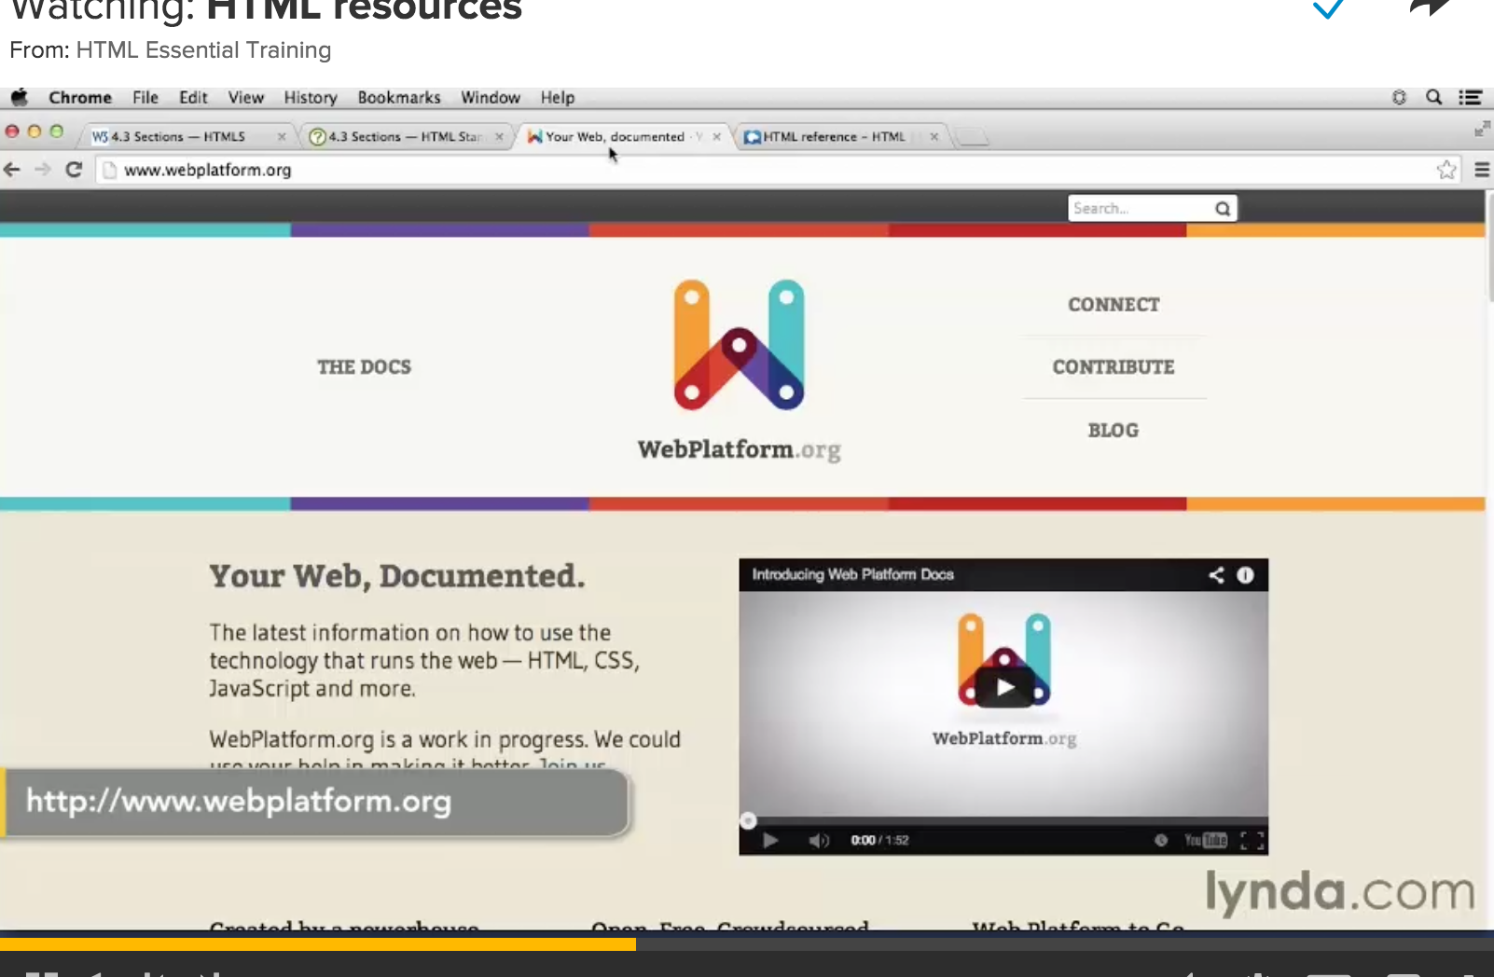

Head = None visual elements. all the things that make the document work.
Title = what will show on the tab

Body = visual content
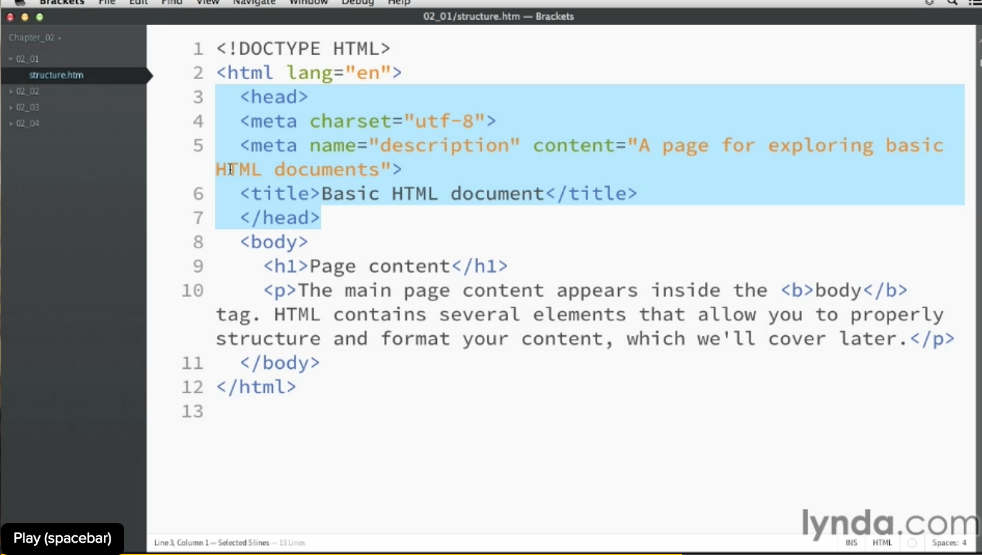

start with the standard doctype
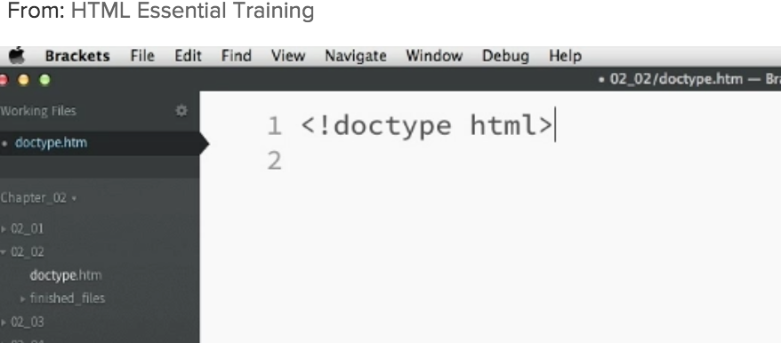

Set the Character set
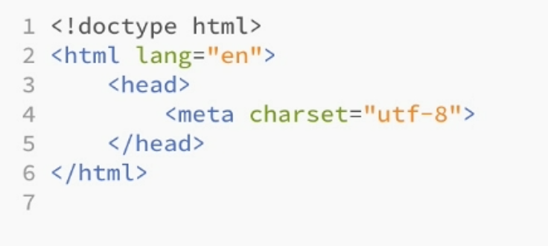

Add a description for search purposes
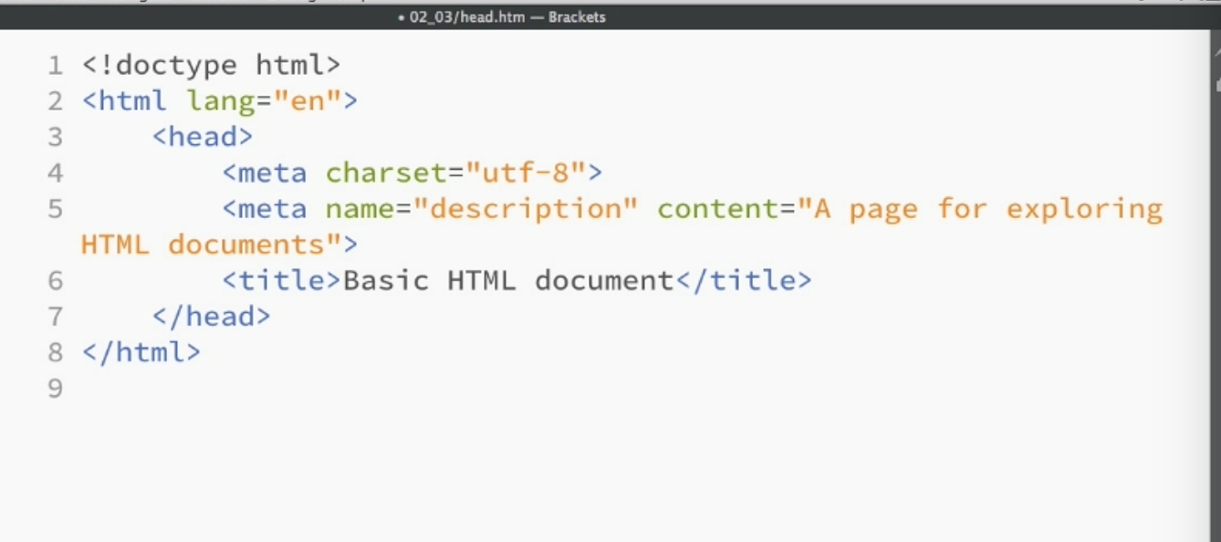

Title tag for the tab
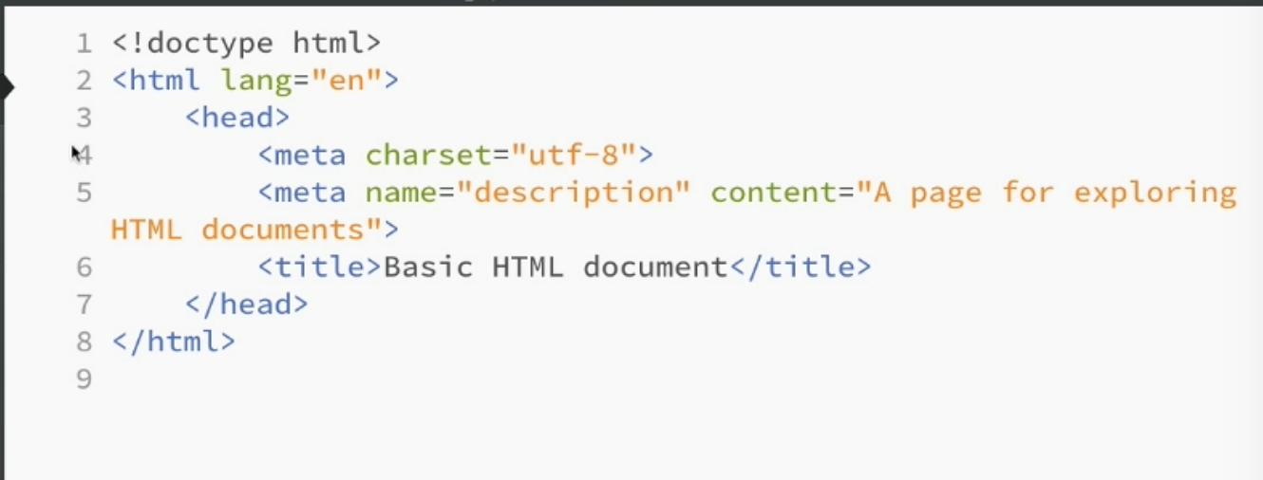

Body is a sibling of the head tag = to it

Content Models

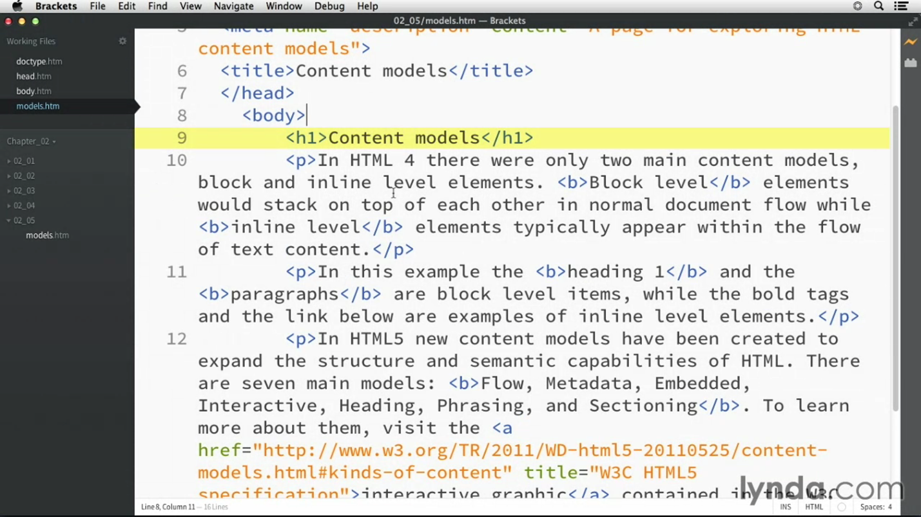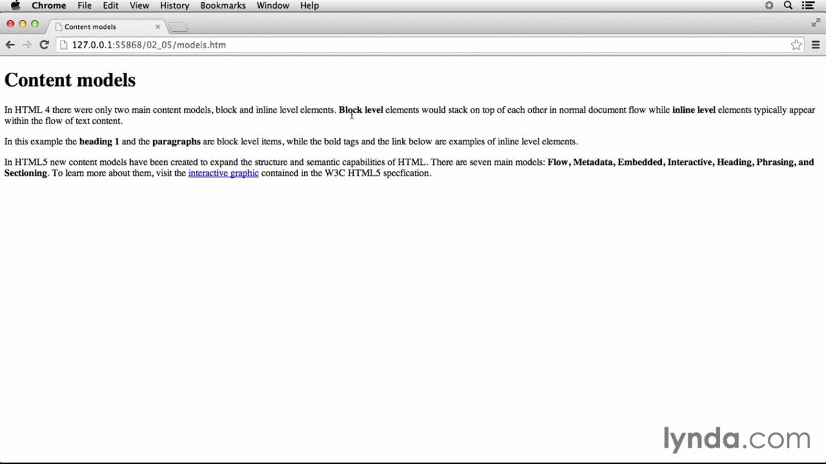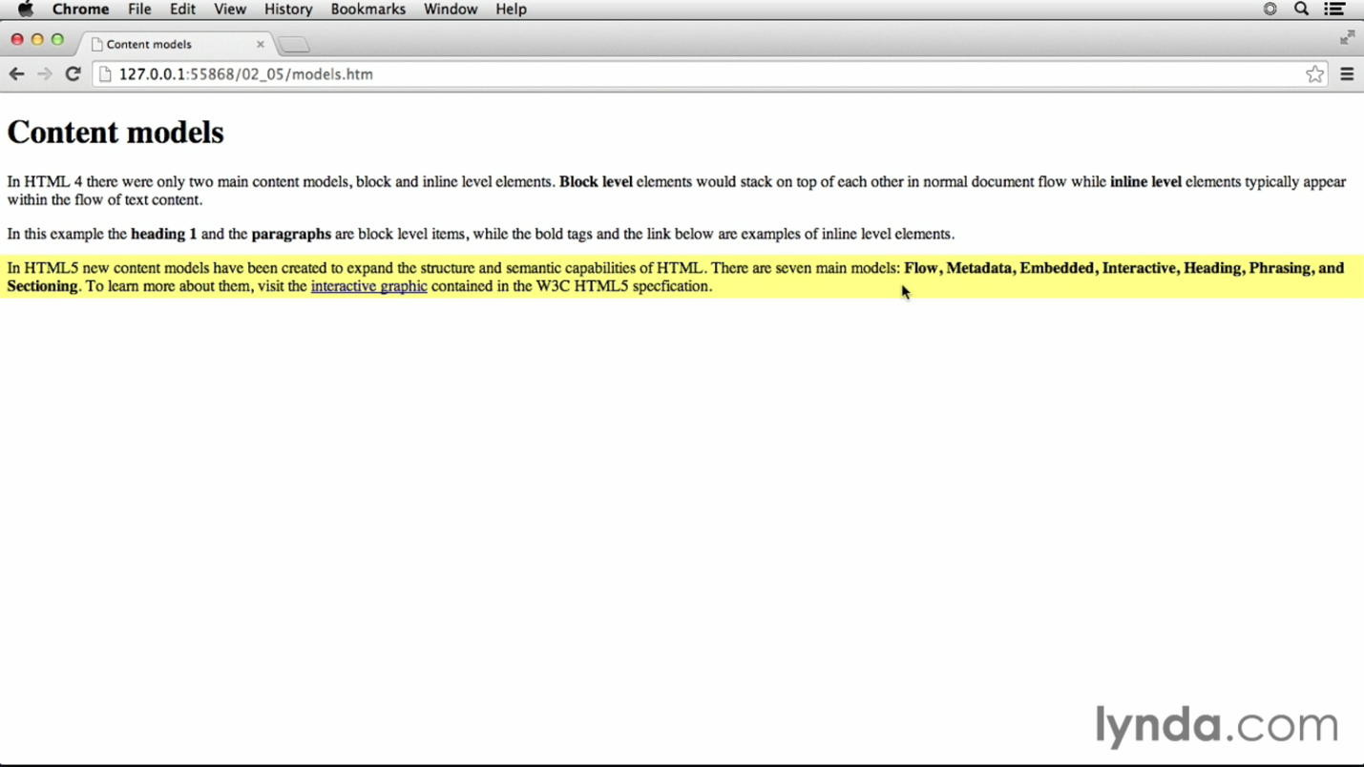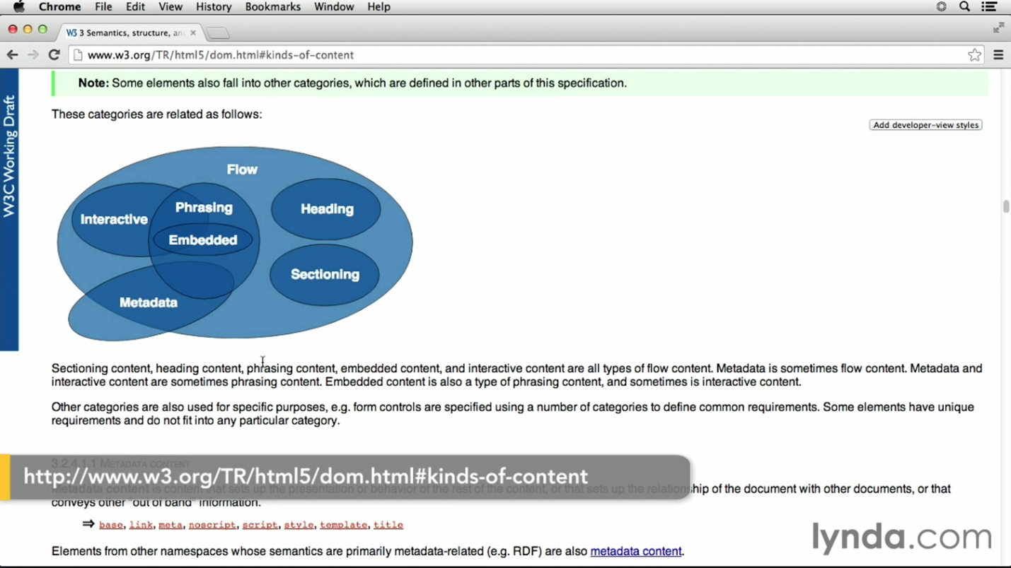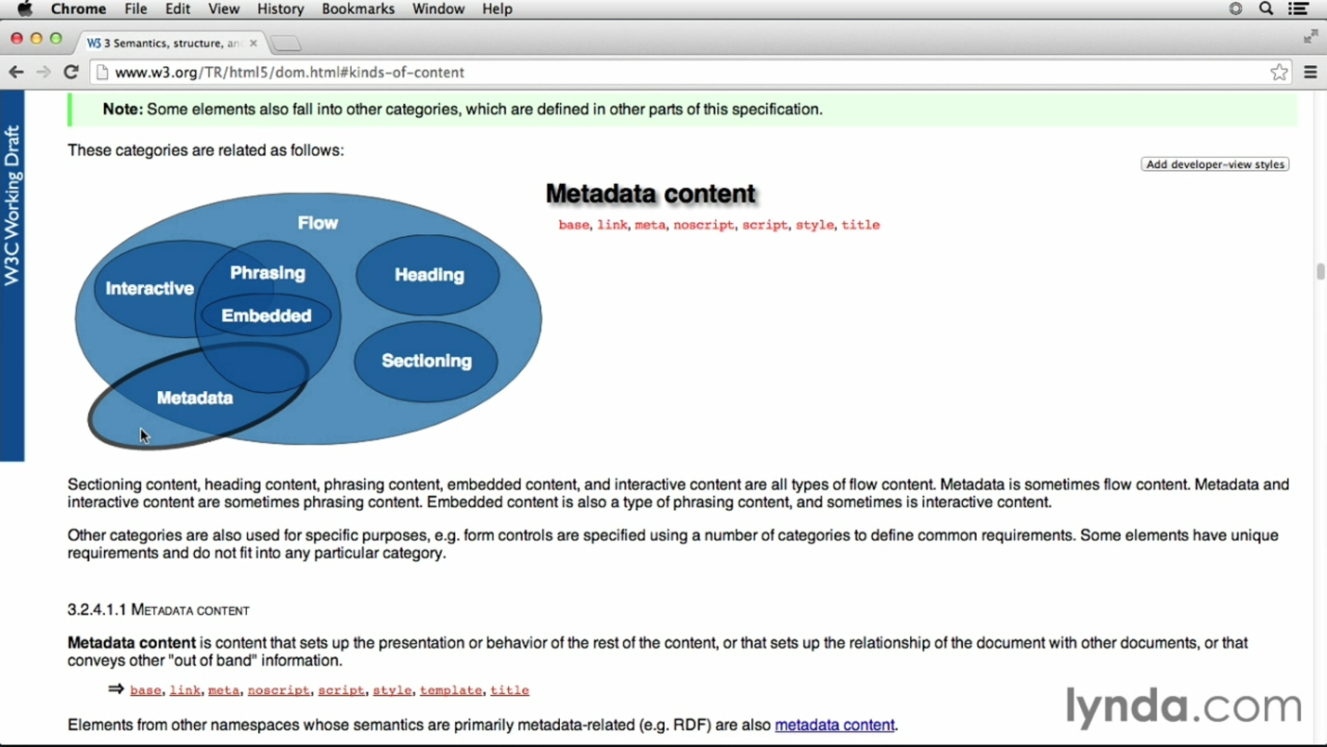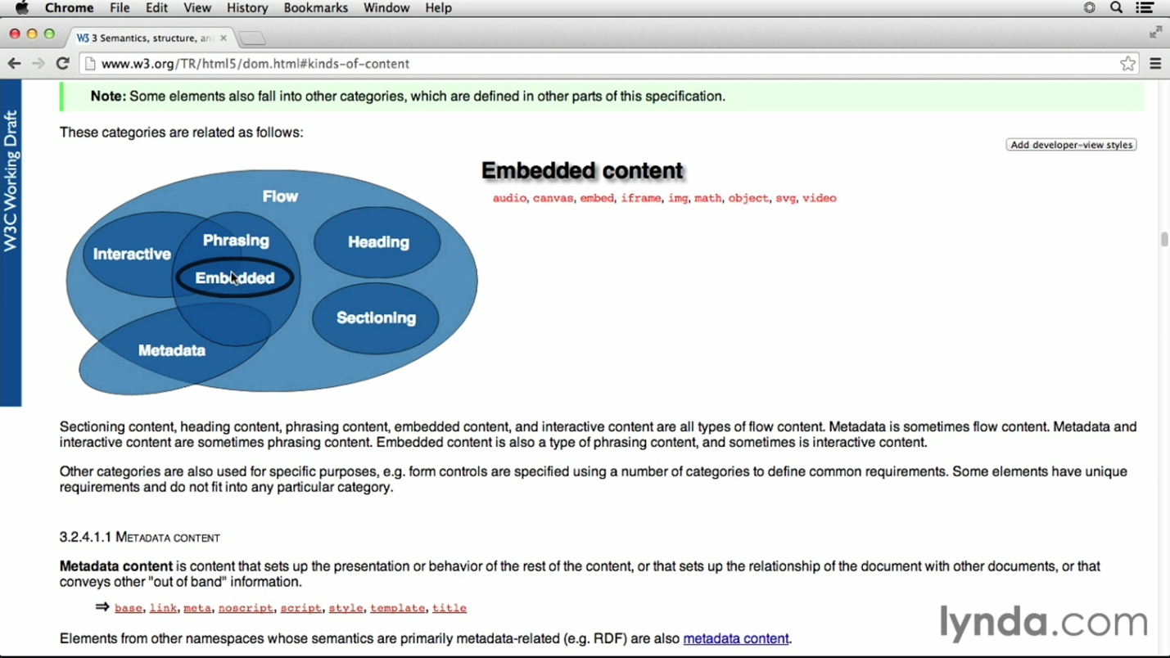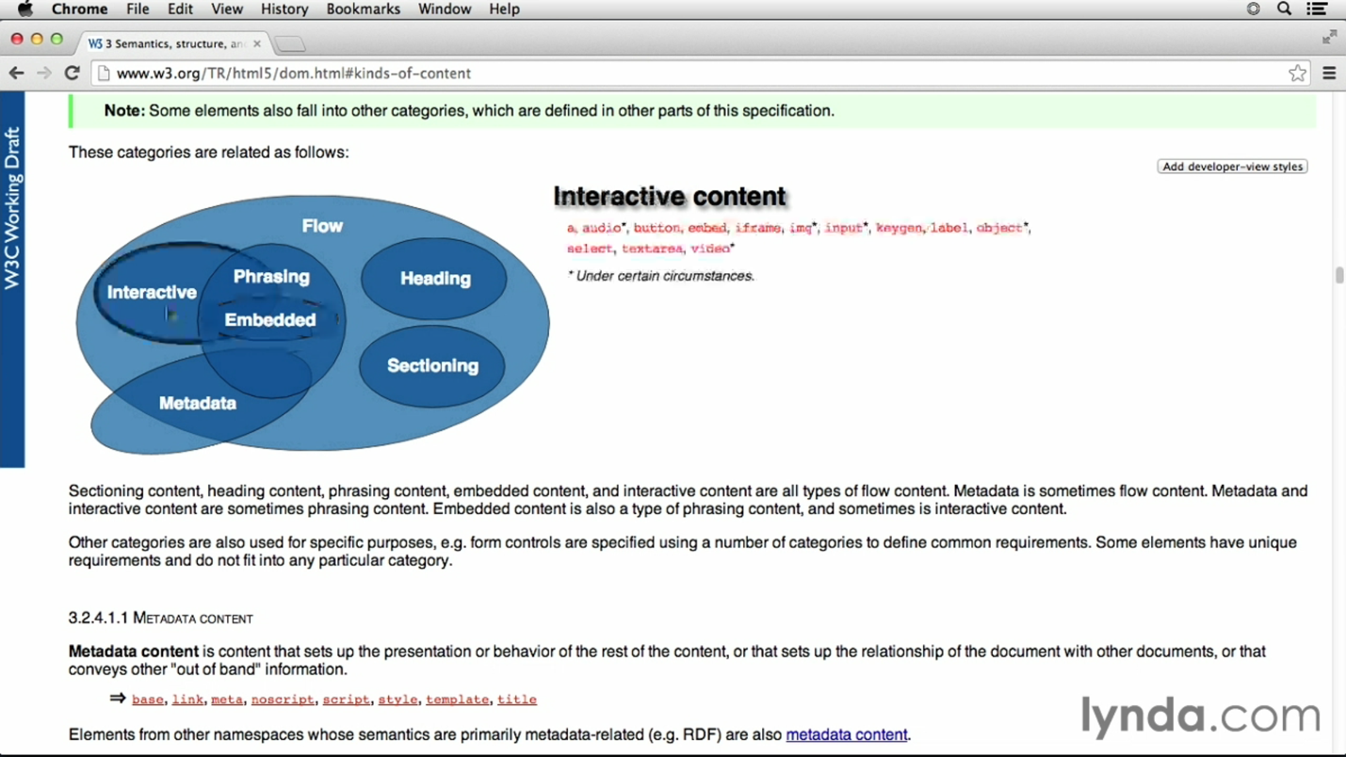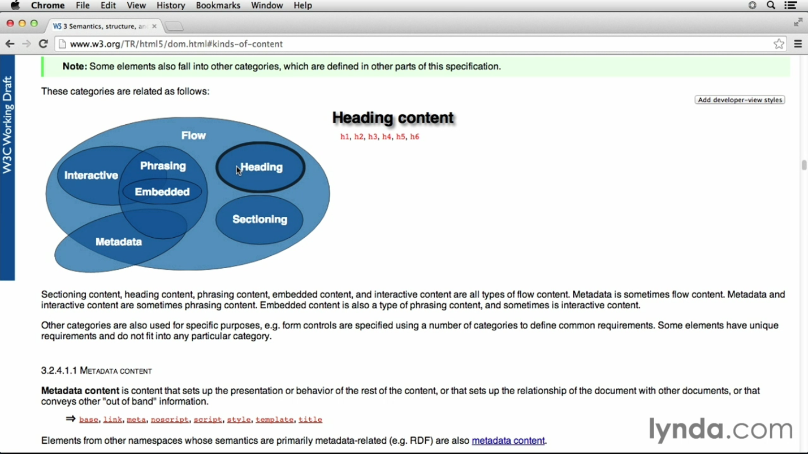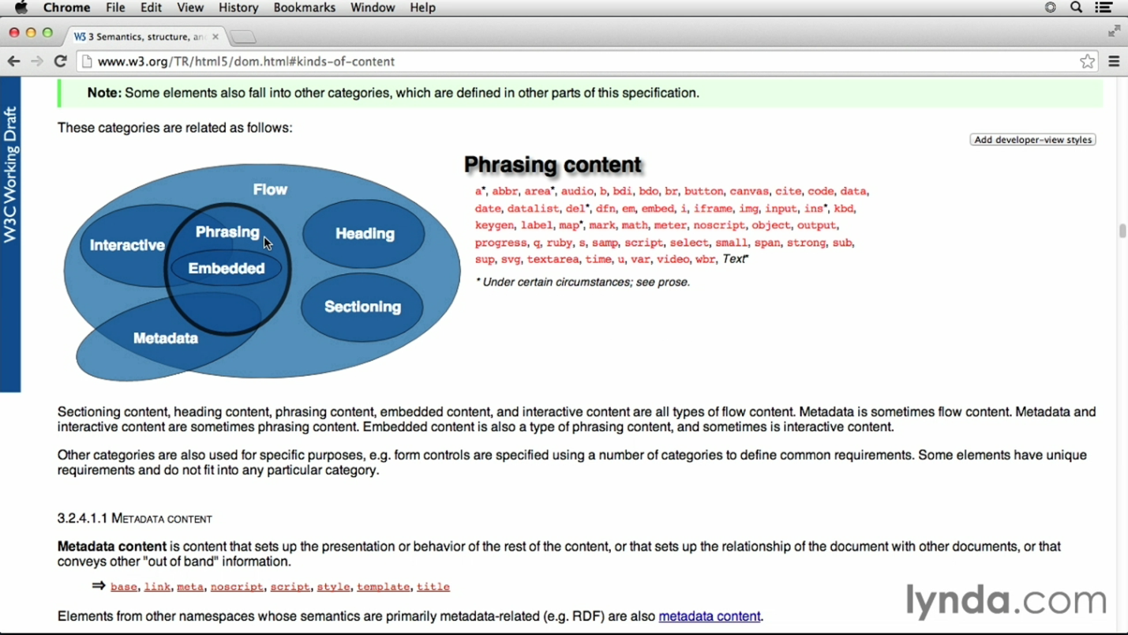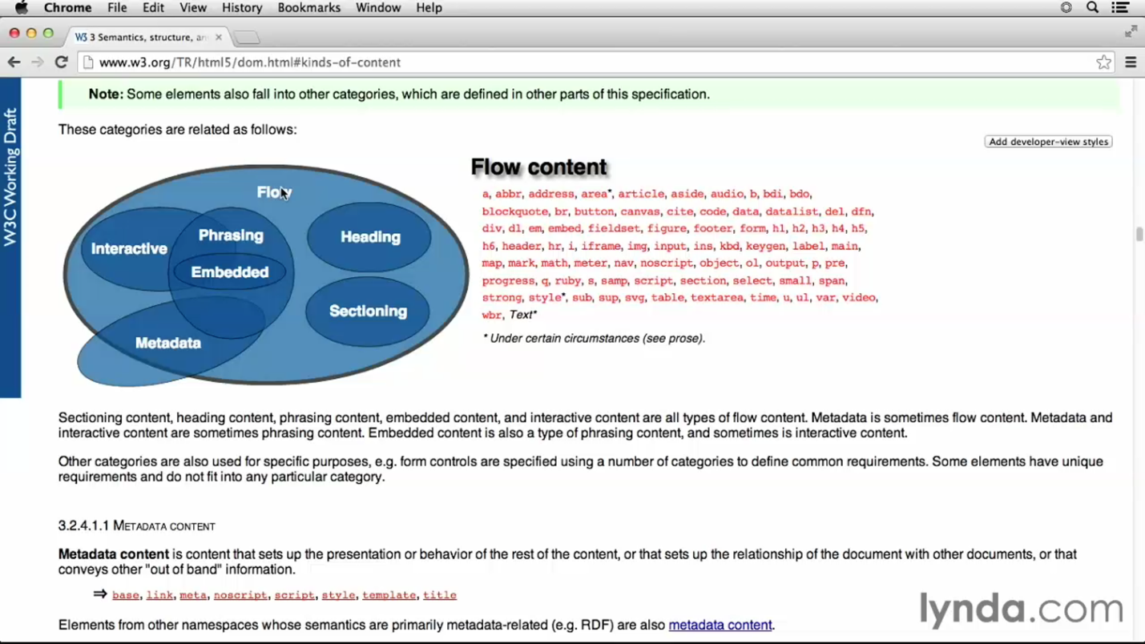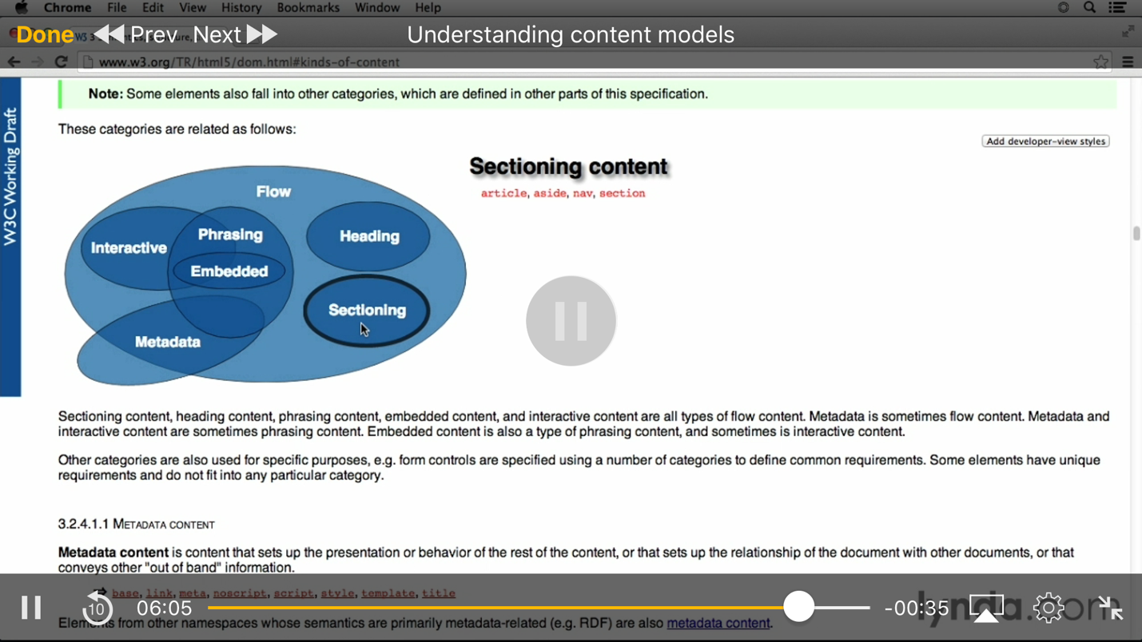

preformatted text = <pre> Makes it so spaces work!!!

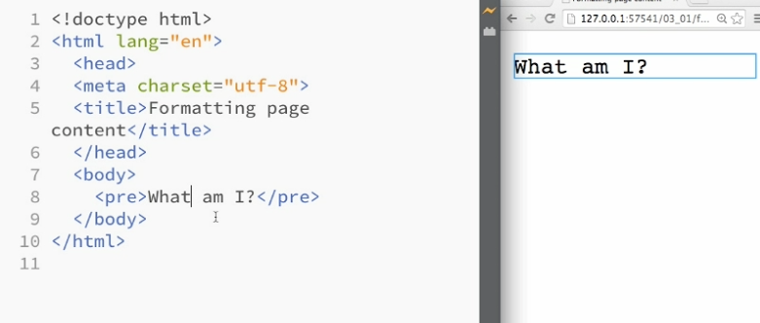

em = emphasize
strong = bold

Headings = Use to classify, CSS will actually change the size and stuff later
Usually always follow the order H1, 2, 3, 4, 5
Think structure, not formatting
Line break = <br>
Keeps things close together

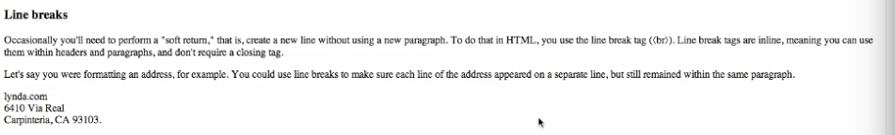

bold =

Strong = <strong> little different than bold, also means that you are strongly emphasizing the text. A screen reader will read it louder

Italics = Like bold, just visual <i>

em = emphasizing the text, also shows up as italisized
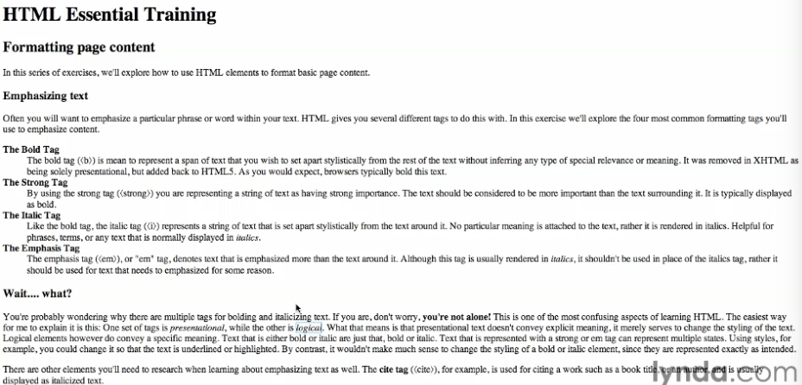

Named character entities

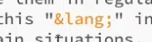

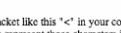

Start with the & and then whatever the symbol is. Go to XML and HTML Character entities in google
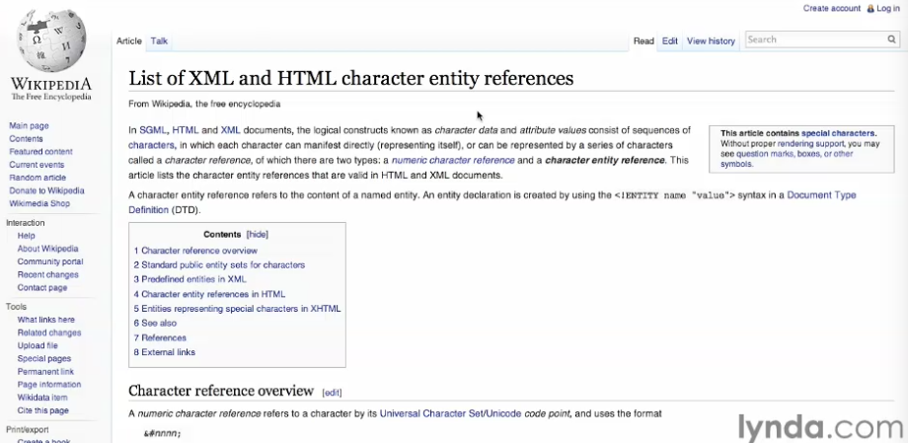

Controlling White space

All white space after the first is ignored

&nbsp; = gives you a space, but you should do most of this stuff with CSS

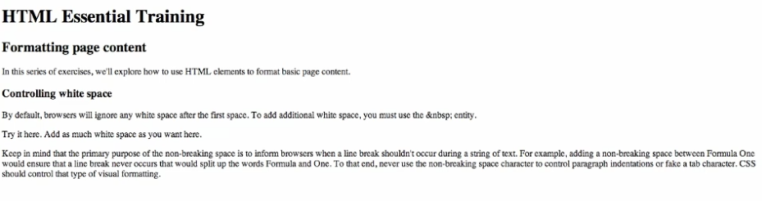
Image
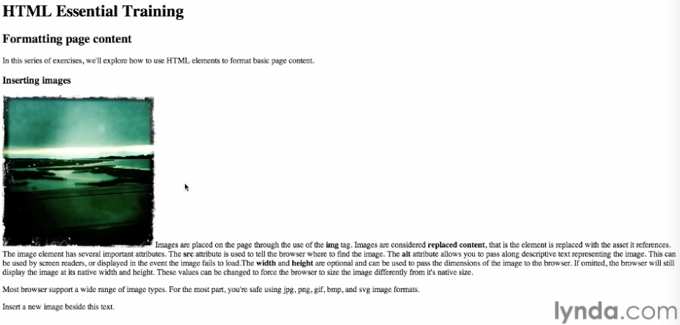

the <img is the tag and it is self closing
Src = is the source or where the image is
Alt is the title so someone with a screen reader will still get something

Structure
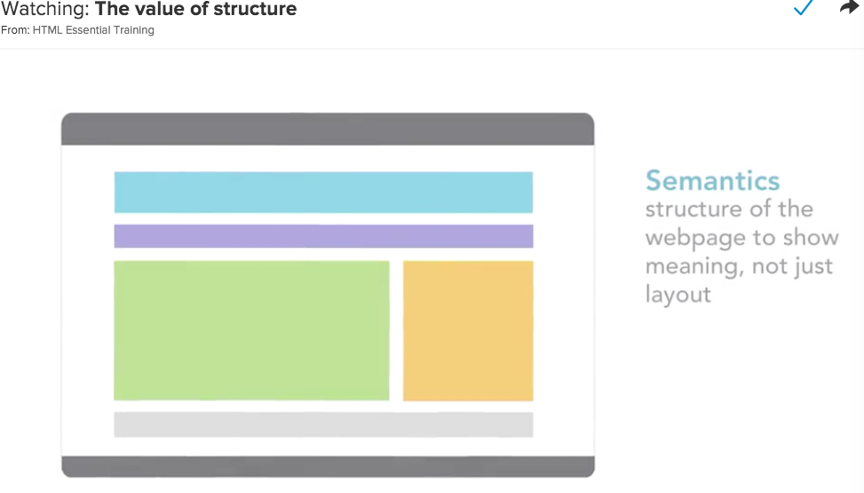

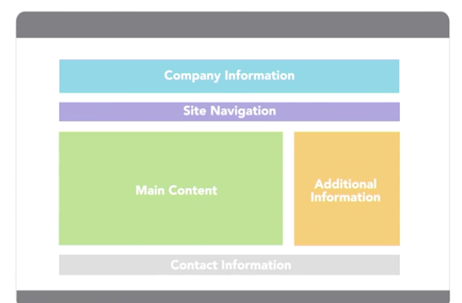

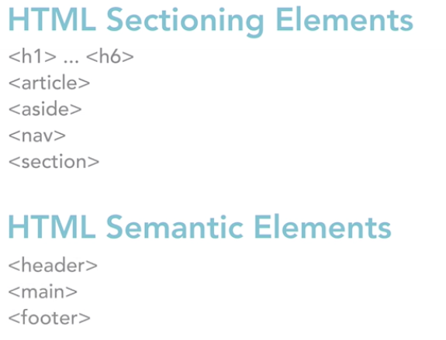

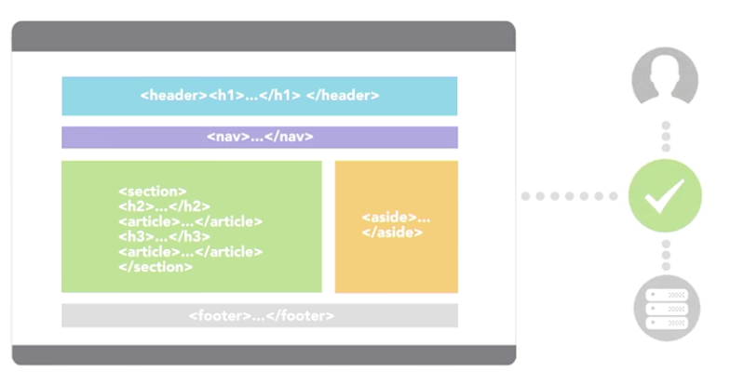

Use your Outline to see all the categories and subcategories 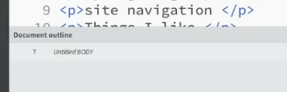

Nav Sectioning Element

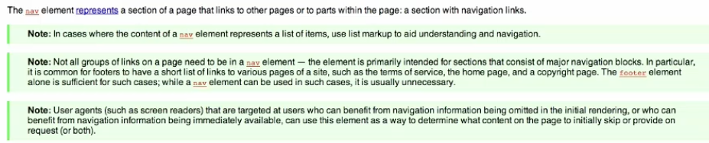

This is a sectioning element only use if you want a new section in your site. Specifically for navigation within your site and not so much for external links.

Article and Sectioning elements

Article Element

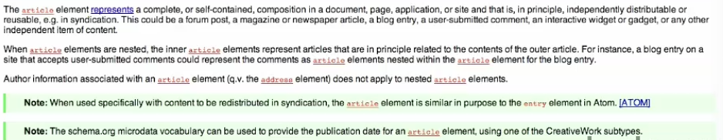

Think of it like an article of clothing. Stand alone Items, that if they were on their own they could stand alone. Nested articles need to be related the parent article.

Section Element
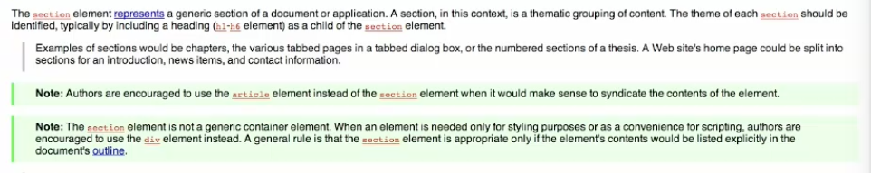
Section Element is used for stuff that is in the document outline, but cannot stand alone like an Article.

Aside Element
Designed for Related content
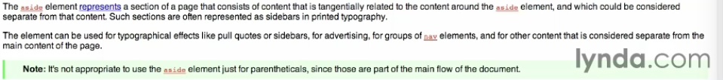

Used for sidebars and stuff like that. Sectional Element Tangentially related content.
Make sure that it is tangentially related to where it is placed. If it is for the whole article, then put it on the outside of the article.

Div Tag

A Tag with no semantics behind it. Used for grouping content.
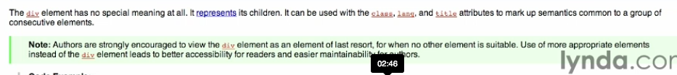

element of last resort, when nothing else fits. If there is a tag that passes on the semantic meaning, then use that instead.

Use a Div Tag and then you can use an id or a class to further specify things…
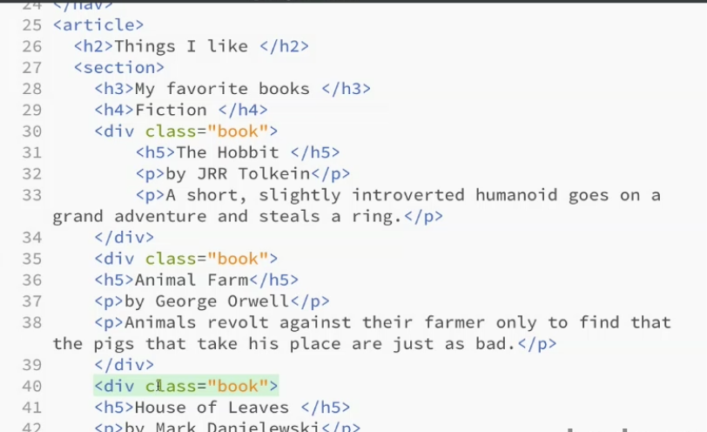

Header Element

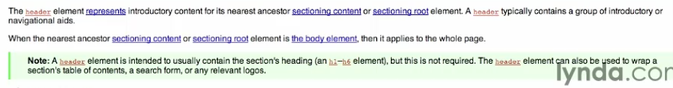
Any time you have a new section of content within your document, those things can go in a header. You can have more than 1 header in a page. Each section can have one.

Footer
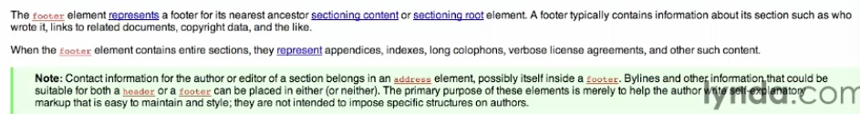

Holding related “extra information” the reader might need. Copywrite info, links to other stuff. You can have as many as you want. Does not have to be at the end of the element.
Main Element

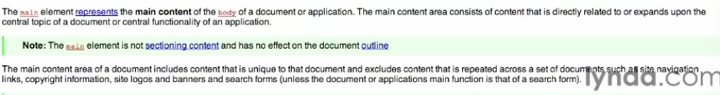

If you are on a screen reader, it can go to that part of the page. Navigational aid for what the main content is.

Aria
Landmark Role Attribute
When you add a role, it allows screen readers to go to that part of the screen.
Banners should only be used once in a document.
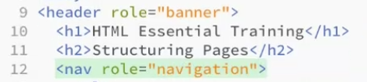

So you give it a role attribute and then the screen reader will know what is going on

