Step 3 Notes

The A tag or anchor tab then href or hypertext reference to tell it where to go

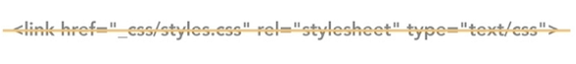

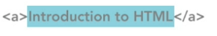

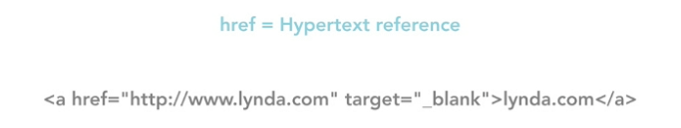

The target attribute is typically used to open a page in a new window or tab, or to control where a page opens within a frame set. Frames are not commonly used in modern web design, and this attribute was actually removed from the HTML specification a while back. Because it has some value in working with web applications, the attribute was returned in the latest HTML 5 specification.

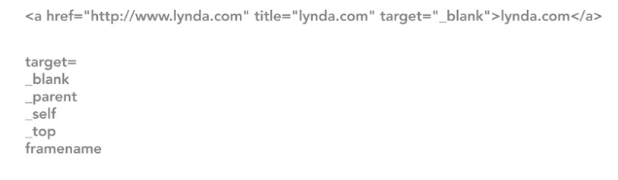

Rel = takes you to the next element

The rel attribute describes the relationship of the target object to the link object. For example, a rel value of, next, would indicate that this link is part of a series, and that the link will take you to the next object or document in the series. HTML 5 has added the new download attribute. This indicates that the link is used to download an external resource or file, such as a PDF or a media file. This attribute is still rather new, so support for it isn't even, or even available across the board.

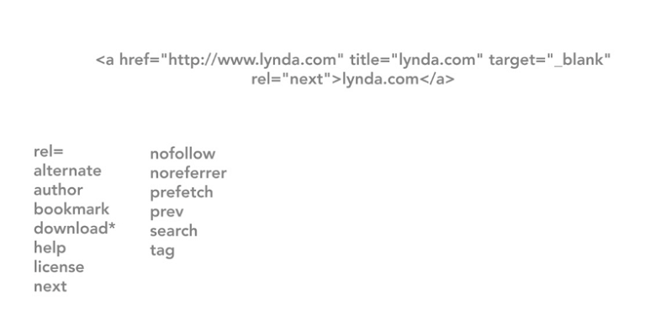

Title = Screen reader

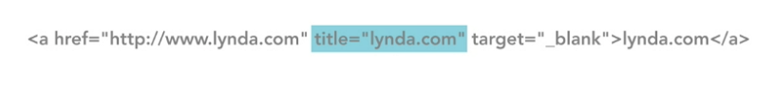

Linking to something in the same directory

Linking to something in a different directory going down just do a / …

To go up a directory use ../

You can go up and down in whatever way that you need to

External Links = Absolute Links
Have to use the whole thing
Make sure and use the title
To open in a new tag use the Target tag… 2nd one

How to Download a file

The browser will open it up if it can, but if you want it to download it then do this
Linking to page Regions = fragment Identifiers

First you have to set an ID for the thing you want to jump to…

Then you link to it with an href #

How to create a link back to the top

How to create a link to go to a section in another page…
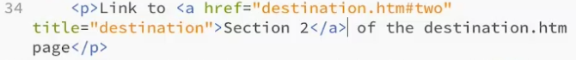
On another site…
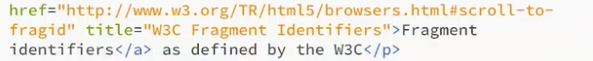

Lists

Unordered List ul tag = primarily a way of grouping information

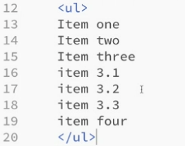

You have to then make each item a list item tag…

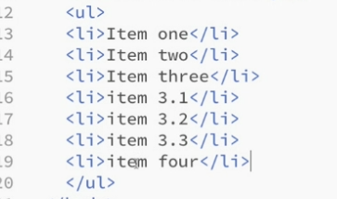

Making a sub list Item…
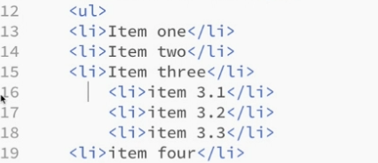

Next cut the closing after the 2 pand pasti it below and then make another unordered list

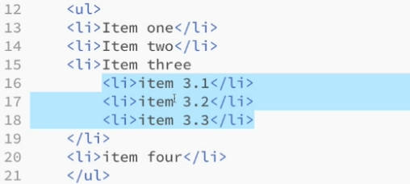

Continued…
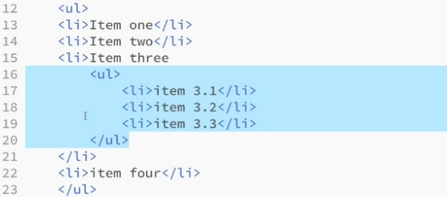

Ordered Lists.

Only thing that you need to do is change it to an OL rather than UL…

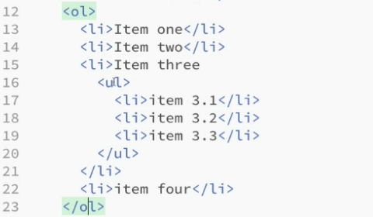

to Start from a different number

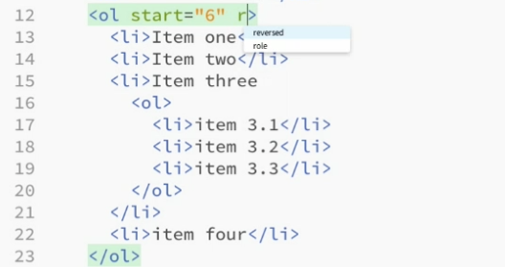

to reverse a list…

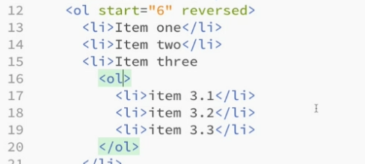

to do a different type…
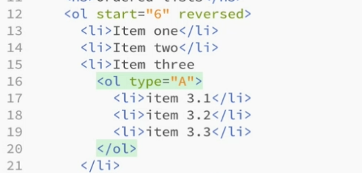

If the sequence matters do an ordered list.

Definition lists is one which has 2 items, a name and a description…
Use a tag of DL and there is a DT (Term) and DD (Description)
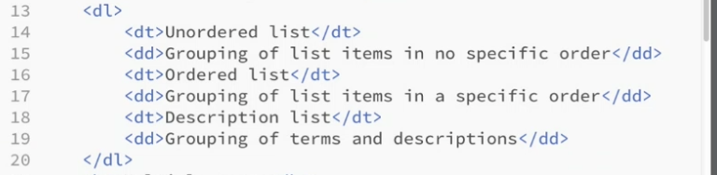

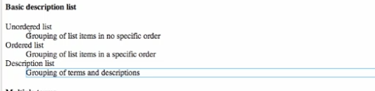

Putting paragraphs in lists…
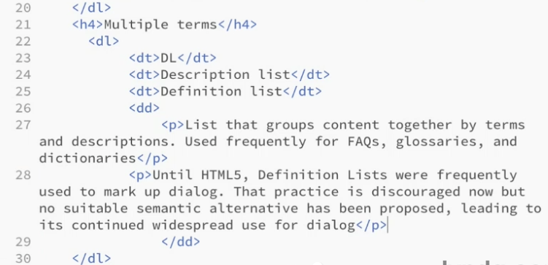
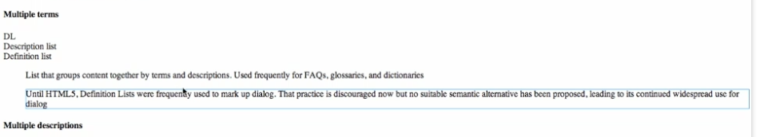

Multiple descriptions

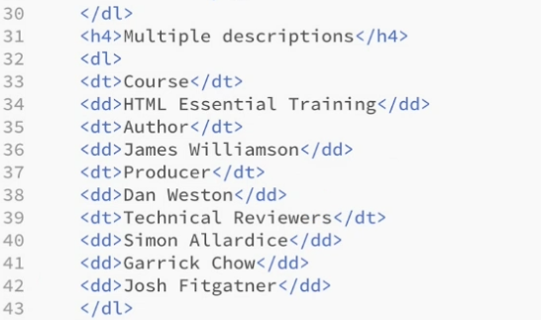

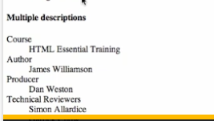

CSS

Overwriting the basic browser style with what you want
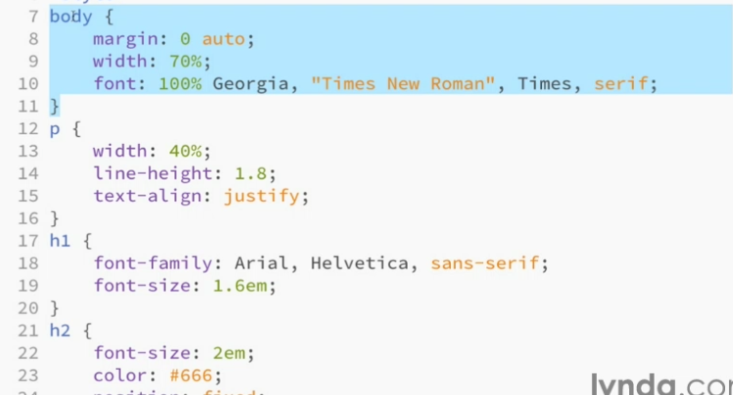

Inline Styles you do it right in with the text (don’t want to do it very much because not good for changing and if you have a lot of pages)

Style Element
Doing it at the top of the page in the head so that it applies to the whole page. Need to use CSS syntax
First Select by writing what you want to change, then use culy brace to put in the properties you want to change… Global Selector

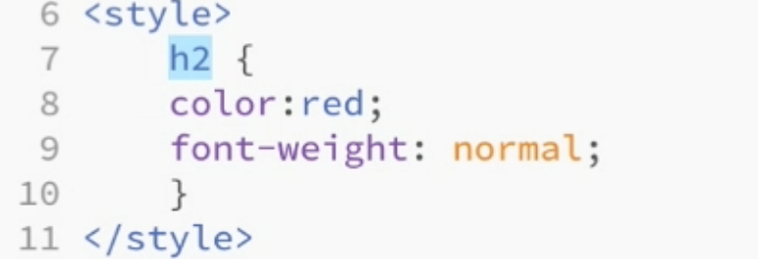

Class Selector, more specific…
.(whatever class you set)
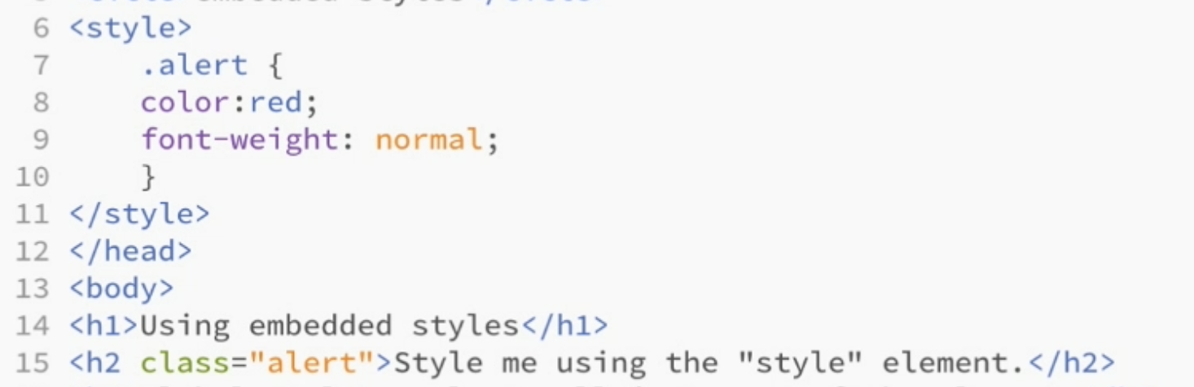

you can combine Global and Class elements

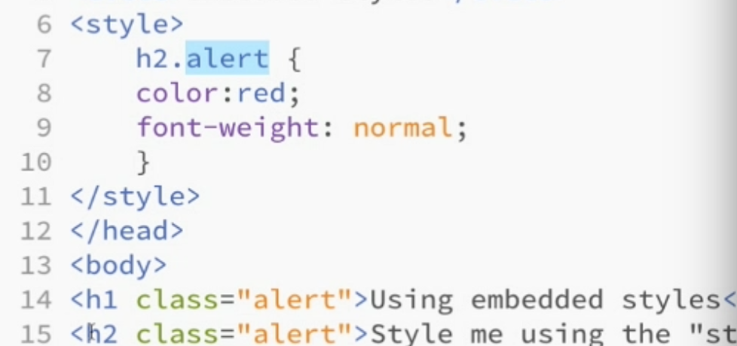

How to Set stuff up..

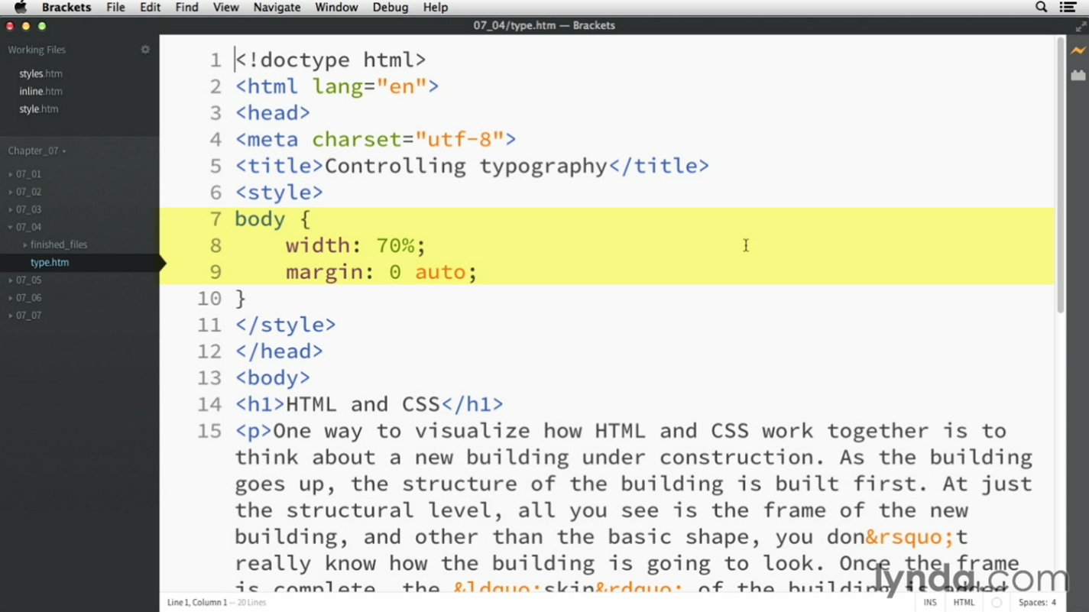

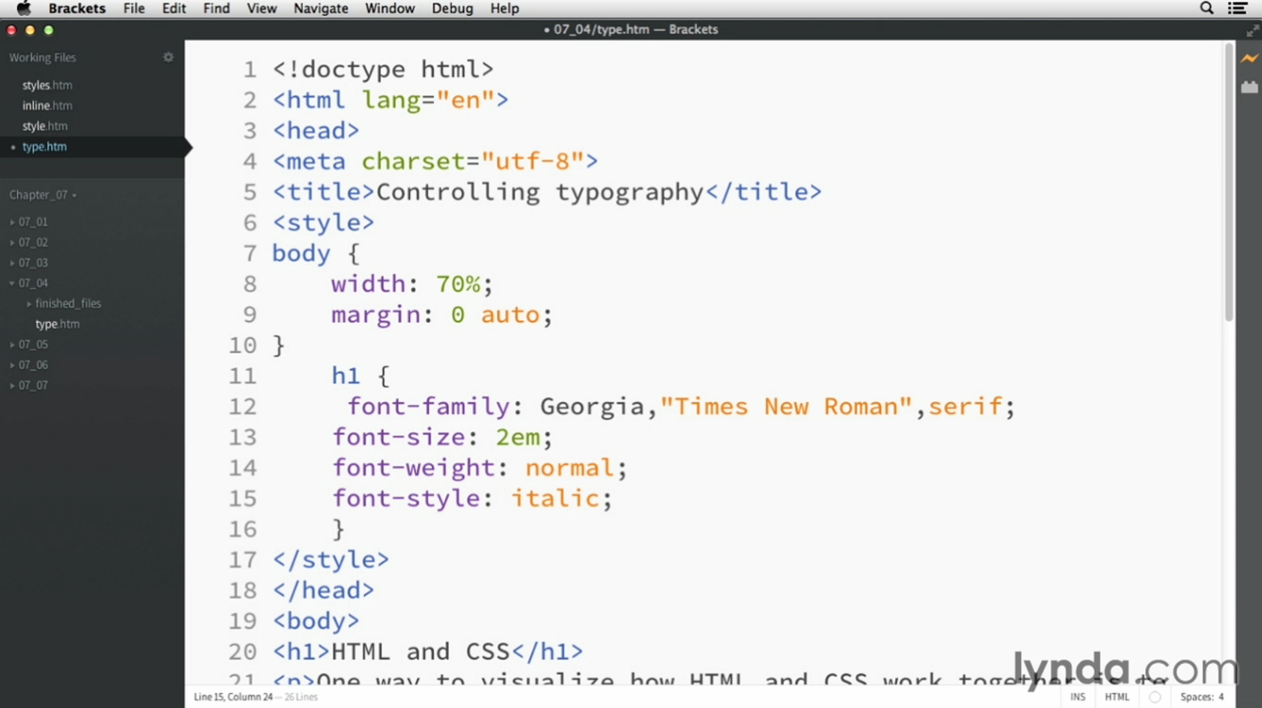

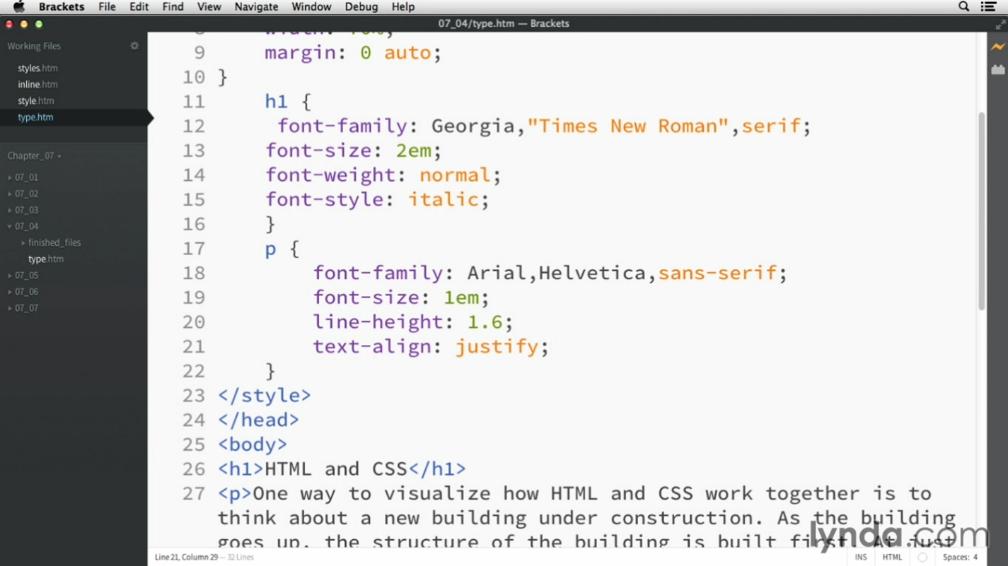

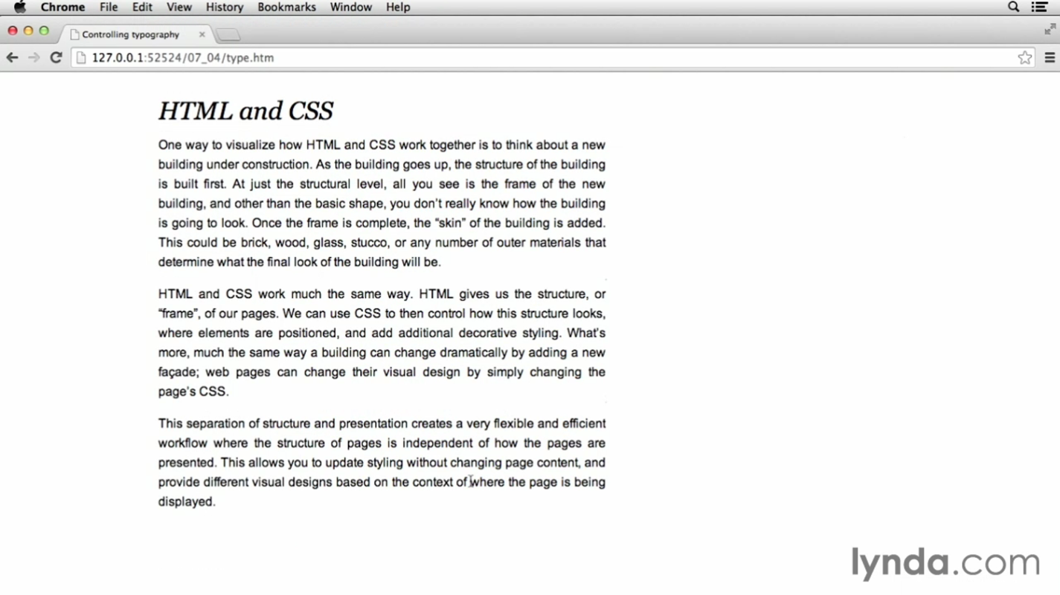
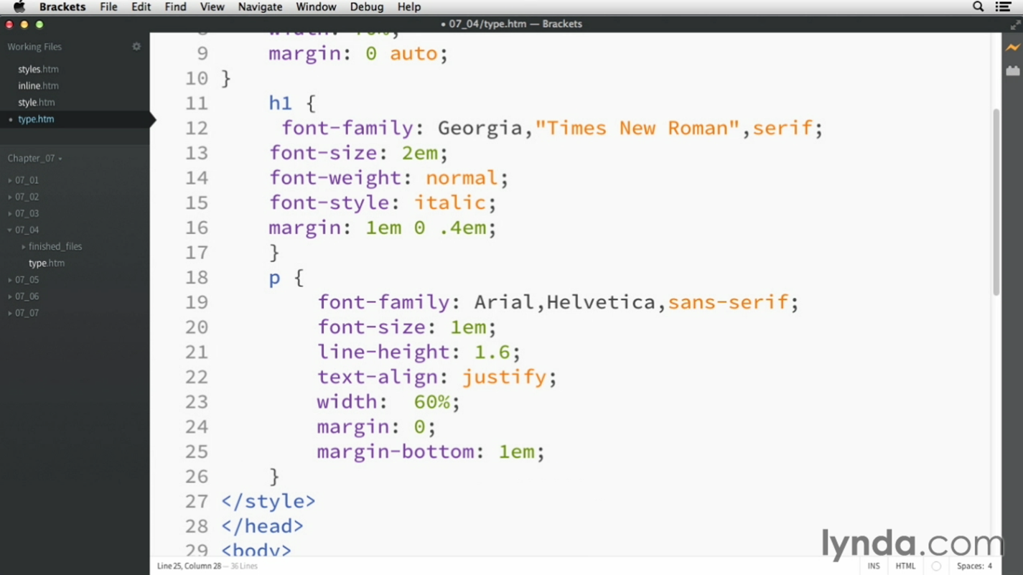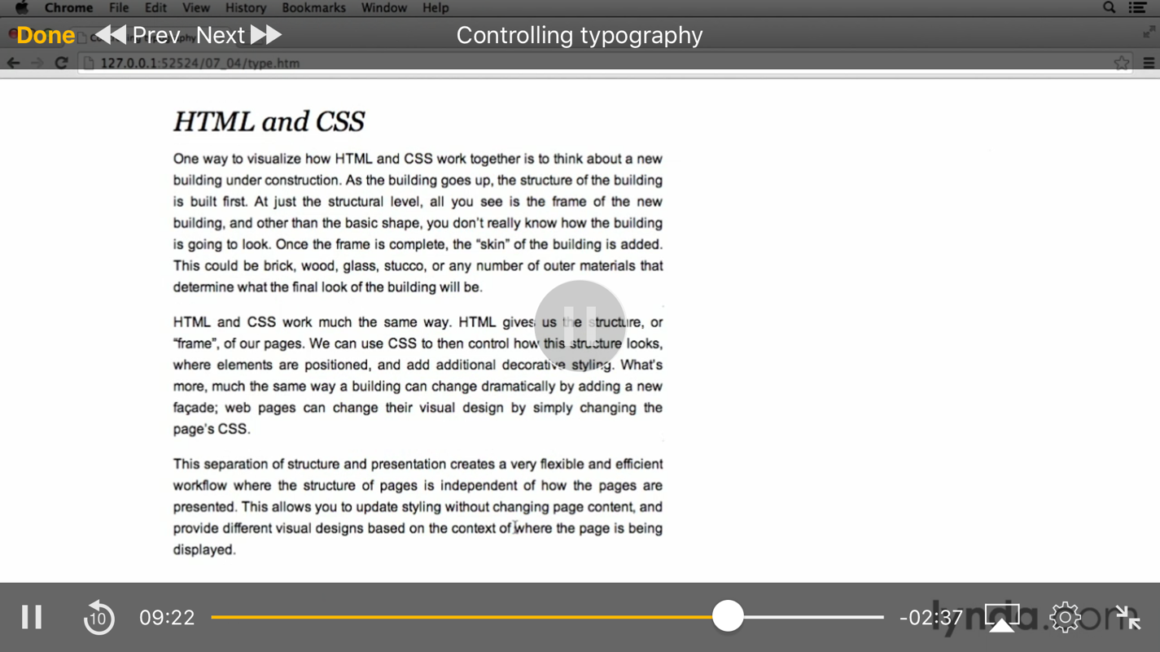

Adding color
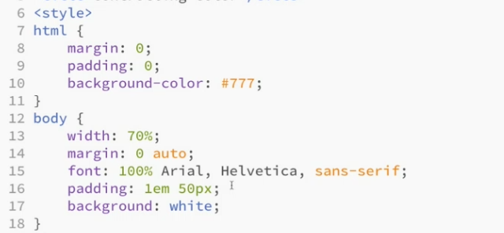

External Styling

Css comment

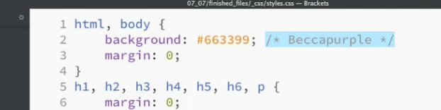

JavaScript

We can use scripting like Css

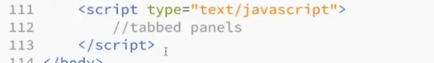

First plan it out with comments

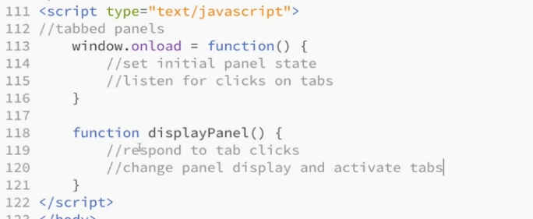

DOM

Document Object Model

Body top of the tree, header child

Variables – whatever you want, will store whatever you want

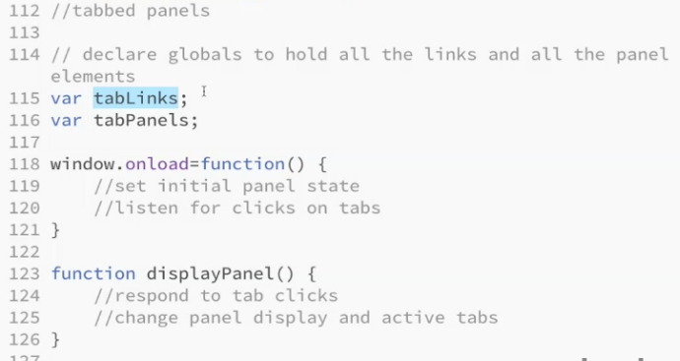

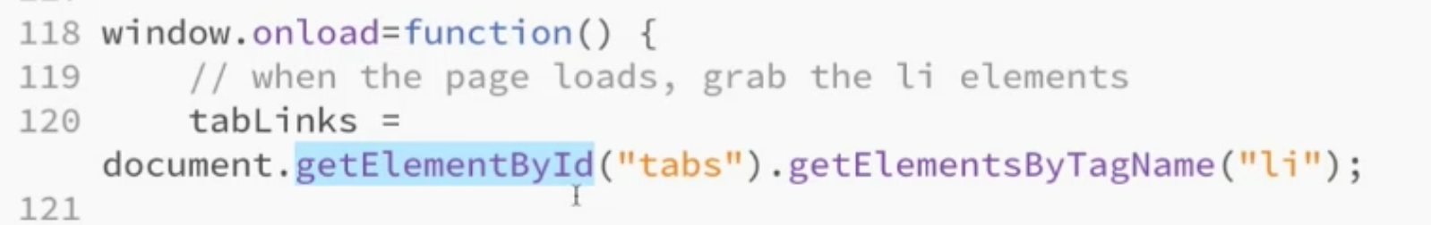

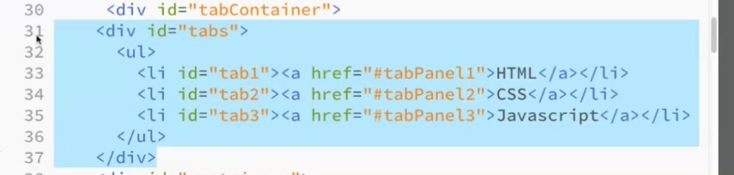

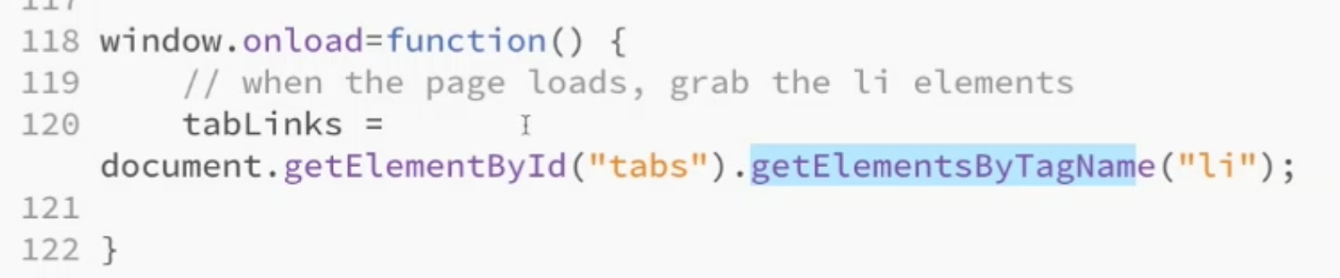

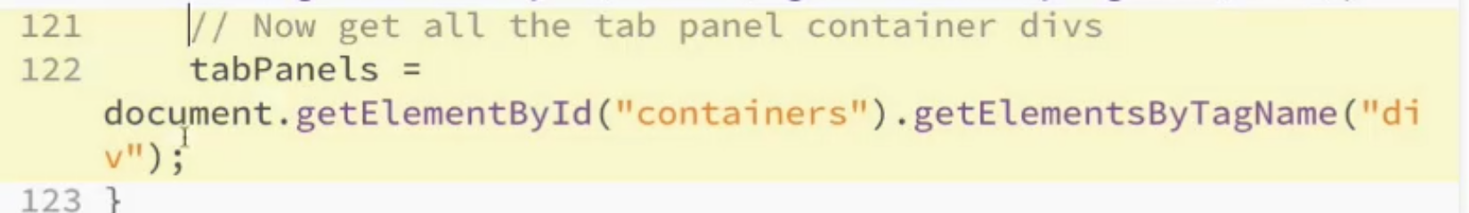

Listening For an Event (a user based event)

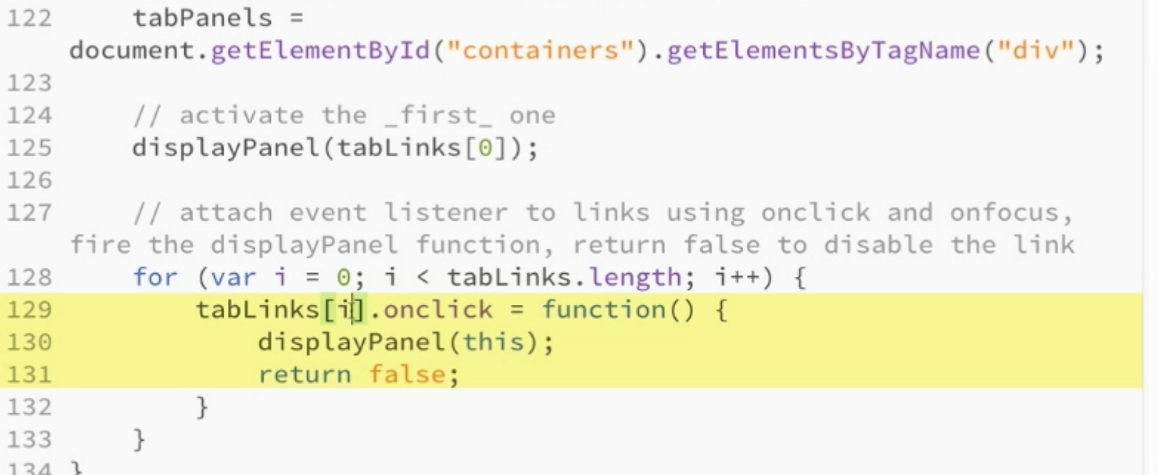

Responding to Events
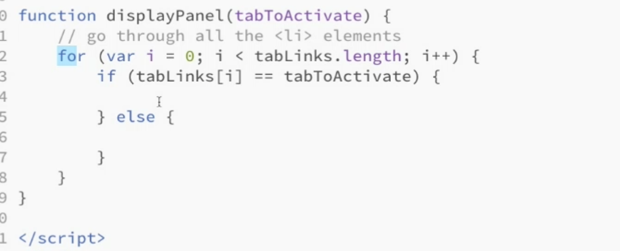

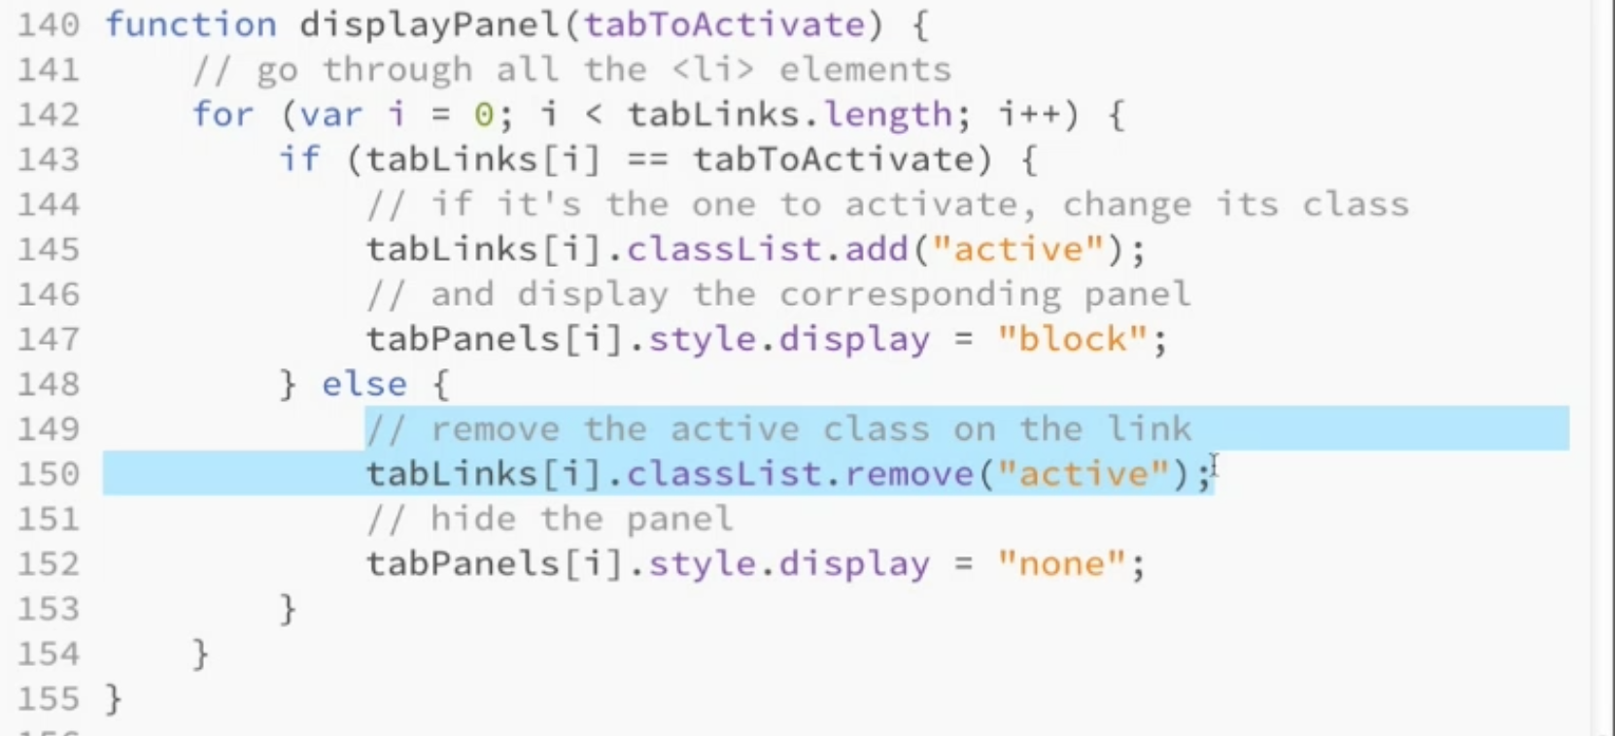

Externalizing Java Script
Works like CSS external stuff
<script src="scripts.js"></script>

